To run this you shall need linqpad (get it from <http://www.linqpad.net/> )

Once you do so go to the sample tab

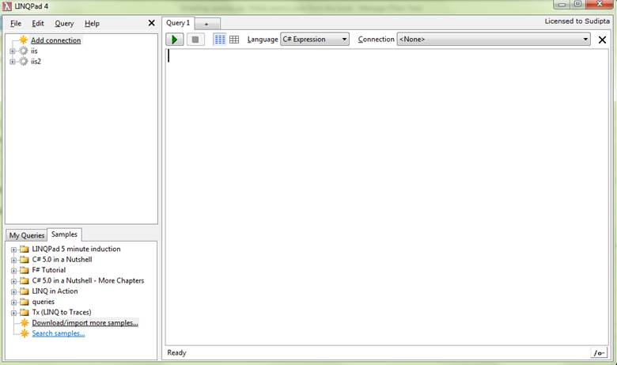

Click on “Download/Import more samples”

And point it to the queries.zip file wherever you save it.

And it will load the queries as shown.

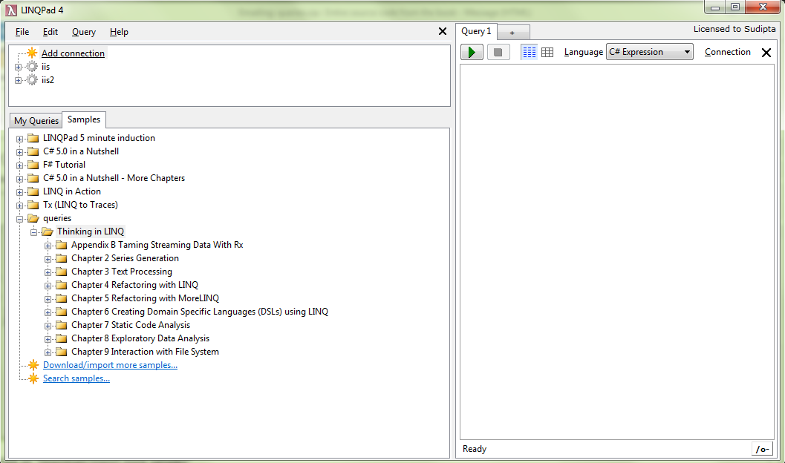

Enjoy!

Sudipta